**Validation Testing**

**Test Data**

In the budgetbuddy_testing.py file is a list of simulated transactions. This list is used to validate the math logic and to test that the view transaction history is working as intended with varying transaction types, categories, and numerical inputs.

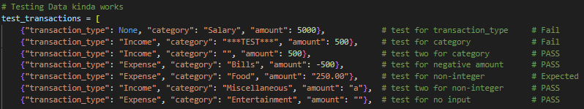

**Results**

This list of transactions can only serve as a test for the math logic and the transaction history window. The failed tests should not be in the transaction history but are still entered into the GUI. The tests that passed triggered the proper error windows to appear and blocked the transaction from being entered. The single expected test was for a try-except with converting the input to a float.

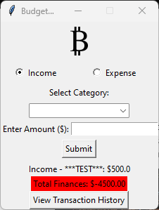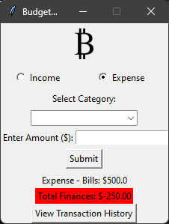

Before and after picture of clicking ok on the Error messages, updates Total finances properly

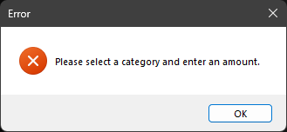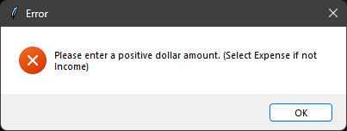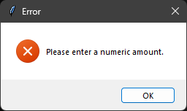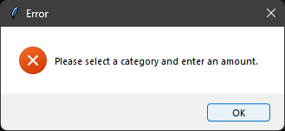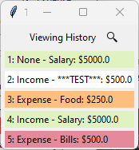

Manual testing was needed for the radio buttons and category selection to ensure validation. Much of this was done as I was learning, so I do not have proper documentation as it was a series of trial and error and much button pressing. I originally had input validation in mind when designing the radio buttons and wanted to require at least one of the choices to be made, however, my original code set the radio button default to ‘None’ which would select both radio buttons instead, this was not code breaking but was visually distracting if a user first opened the GUI. I opted to default the starting transaction type to income. My validation for category selection is a simple ‘if’ statement checking if both a category and a numeric amount have been received, this test works when there is no category input, but does not if a category was typed manually so I chose to limit the field to read-only to prevent this.

There are two more transactions listed in the history.



These are normal inputs that work as expected and are properly displayed in the transaction history.